# 

**First Law of Thermodynamics:** **3**

**Polytropic Processes:** **3**

**Polytropic Ideal Gasses:** **3**

**Ideal Gases:** **4**

**Approximating Ideal Gases:** **5**

**Thermodynamic Cycles:** **6**

**Vapor Dome:** **6**

Interpolation (Linearization): 6

**Heat Transfer:** **8**

**Types of Power:** **8**

**Open Systems:** **9**

At steady state: 9

**Engineering Devices:** **10**

Nozzle/Diffuser (if Q = 0) 10

Turbine/Compressors/Pumps/Fans (if Q = 0) 10

Throttling devices: decrease the pressure (if Q = 0) 10

Heat exchanger: 11

**Second Law of Thermodynamics:** **11**

**Entropy:** **11**

Incompressible Liquid: 12

Ideal Gases: 12

**Efficiency/Coefficient of Performances:** **12**

**Carnot Cycle:** **13**

**Rankine Cycle:** **13**

Ideal Rankine Cycle: =Wcycle/mQin/m 13

Superheated Rankine Cycle: 14

Reheat Rankine Cycle: 14

**Brayton Cycle:** **17**

Regenerative Gas Turbine: 18

Reheat gas turbines: 19

Intercooled gas: 19

Pressure ratio: 19

Ericsson Cycle: 20

**Reciprocating engine equations:** **20**

Break Power Output 20

Mean Effective Pressure: 20

**Otto Cycle:** **20**

Cold Air Otto: 21

**Diesel cycle:** **21**

Cold Air Diesel: 21

**Dual Cycle:** **22**

**Ideal Stirling cycle:** **22**

**Refrigeration cycles:** **23**

Vapor-Compression refrigeration: 23

**Moist Air** **24**

Partial pressure 24

Properties 24

Humidity ratio 24

Relative humidity 24

Dew point temperature 25

**Psychrometric chart:** **25**

# 

# 

# First Law of Thermodynamics:

Change in energy = Heat - Work

$ΔU=Q-W$

For cycles that start and end at same point, $ΔU$ = 0

${(+) Q}_{in}$ $(-) W_{in}$

$(-) Q_{out}$ $(+)W_{out}$

For a steam engine, we want heat in and work out, thus those are the positive values.

in: from surrounding to system out: from system to surrounding

|  | Metric | English |
| --- | --- | --- |
| Work | kJ | Btu |
| $PΔv=W$ | $bar*m^{3}*10^{2}=kJ$ |  |

Audiobatic: $Q=0$

# Polytropic Processes:

$Pv^{n}=Constant$ $P_{1}{v_{1}}^{n}=P_{2}{v_{2}}^{n}$

$P={\frac{P_{1}v_{1}}{v^{n}}}^{n}$

$n=ln(\frac{P_{1}}{P_{2}})÷ln(\frac{v_{2}}{v_{1}})$

| Always | $w=\int_{v_{1}}^{v_{2}}{}Pdv$ |
| --- | --- |
| $n=1$ | $w=P_{1}v_{1}ln\frac{v_{2}}{v_{1}}$ |
| $n≠1$ | $w=\frac{P_{2}v_{2}-P_{1}v_{1}}{1-n}$ |

# Polytropic Ideal Gasses:

$P_{1}v_{1}=RT_{1}$

| Isothermal: $n=1$ | $w=P_{1}v_{1}ln\frac{v_{2}}{v_{1}}$ | $w=RT_{1}ln\frac{v_{2}}{v_{1}}=$ $RT_{1}ln\frac{P_{1}}{P_{2}}$ |
| --- | --- | --- |
| $n≠1$ | $w=\frac{P_{2}v_{2}-P_{1}v_{1}}{1-n}$ | $\frac{1}{1-n}R(T_{2}-T_{1})=c_{v}(T_{2}-T_{1})$ |

$n=k=\frac{c_{p}}{c_{v}}$

# Ideal Gases:

$P\bar{v}=\bar{R}T$ $\bar{R}=8.314\frac{kJ}{kmol*K}=1.986\frac{Btu}{lbmol*^{o}R}$ $Pv=RT$ $R=\frac{\bar{R}}{MolarMass}$

Ideal gases are far from the vapor dome

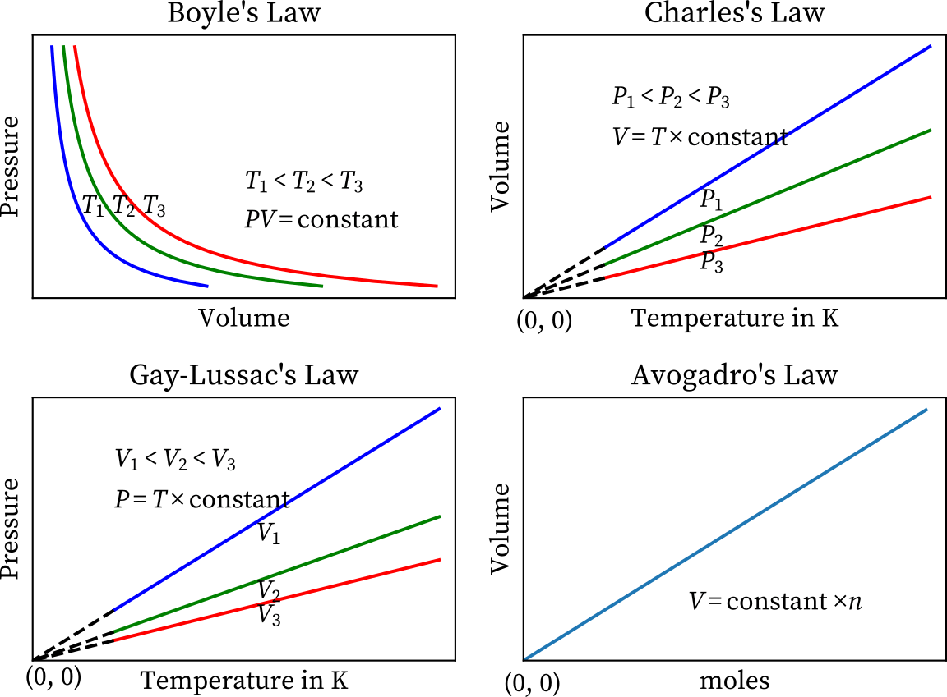

$u$, and all other properties are only defined by T

$u(P,T)=u(T)$

$h=u+Pv=u(T)+RT$

$c_{v}=\frac{du(T)}{dT}$ $c_{p}=\frac{dh(T)}{dT}$

$c_{v}=\frac{R}{k-1}$ $c_{p}=\frac{kR}{k-1}$ $c_{p}-c_{v}=R$

If $c_{v}$ and $c_{p}$ are constant-ish: Not large change in $T_{1}$ and $T_{2}$

$Δu=c_{v}(T_{2}-T_{1})$ $Δh=c_{p}(T_{2}-T_{1})$

# Approximating Ideal Gases:

Compressibility factor: $z_{c}=\frac{RT}{Pv}$ If $0.95<z_{c}<1$, then you can assume Ideal

Reduced Values, look at compressibility chart:

$P_{R}=\frac{P}{P_{c}}$ $T_{R}=\frac{T}{T_{c}}$

“c” values by substance can be found in a table

$v_{R}'=\bar{v}÷(\frac{\bar{R}T_{c}}{P_{c}})$

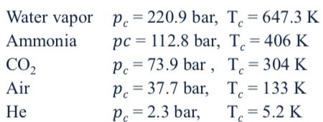

Specific heat, general:

When volume is constant: $c_{v}=\frac{∂u}{∂T}(T,v)$

When pressure is constant: $c_{p}=\frac{∂h}{∂T}(P,v)$

$c_{p}=\frac{dh}{dt}=\frac{du}{dt}+R\frac{dT}{dT}$ $c_{p}=c_{v}+R$

$k=\frac{c_{p}}{c_{v}}$

# Thermodynamic Cycles:

Note: we are taking the absolute values of $Q_{in}$ and $Q_{out}$ for these below:

| Power Cycle | $η$ | $\frac{W_{cycle}}{Q_{in}}$ | $\frac{Q_{in}-Q_{out}}{Q_{in}}$ | $1-\frac{Q_{out}}{Q_{in}}$ | $W_{cycle}=Q_{in}-Q_{out}$ |
| --- | --- | --- | --- | --- | --- |
| Refrigeration Cycles | $β$ | $\frac{Q_{in}}{W_{cycle}}$ | $\frac{Q_{in}}{Q_{out}-Q_{in}}$ |  | $W_{cycle}=Q_{out}-Q_{in}$ |
| Heat Pump | $γ$ | $\frac{Q_{out}}{W_{cycle}}$ | $\frac{Q_{out}}{Q_{out}-Q_{in}}$ | $(1-\frac{Q_{in}}{Q_{out}})^{-1}$ | $W_{cycle}=Q_{out}-Q_{in}$ |

$γ=β+1$

Power Cycle: Tradition cycle, take heat and give out work

Refrigeration cycle: Use work to take heat out of something cold, making it colder

Heat Pump: Use work to heat up from something cold/neutral to make something hot

# Vapor Dome:

$v=v_{f}+x(v_{g}-v_{f})$ $x=\frac{v-v_{f}}{v_{g}-v_{f}}$ 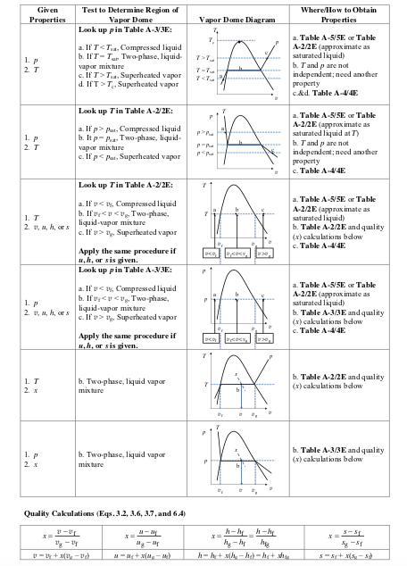

## Interpolation (Linearization):



$y=\frac{y_{2}-y_{1}}{x_{2}-x_{1}}(x-x_{1})+{y_{1}}_{}$ $\frac{y-y_{1}}{x-x_{1}}=\frac{y_{2}-y_{1}}{x_{2}-x_{1}}$

# Heat Transfer:

Conduction:

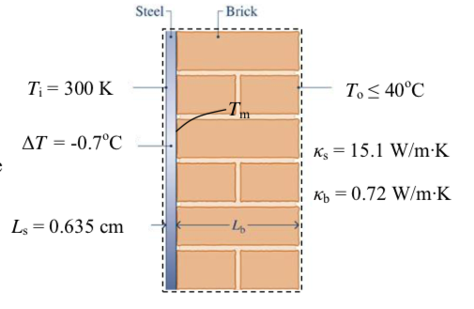

$\dot{Q}=\frac{-AkΔT}{L}$ $\frac{\dot{Q}}{A}=\frac{-kΔT}{L}$

$\dot{Q}$ is the same for the whole material: $\dot{Q}=(\frac{-AkΔT}{L})_{Steel}=(\frac{-AkΔT}{L})_{Brick}$

Convection:

$\frac{\dot{Q}}{A}=h(T_{Surface}-T_{surrounding})$

Radiation:

$\dot{Q}=ϵAσ({T_{Surface}}^{4}-{T_{surrounding}}^{4})$ $σ=5.67*10^{-8}\frac{W}{m^{2}K^{4}}$ $ϵ$ based of surface

# 

# Types of Power:

${\dot{W}}_{electrical}=(amps)(Volts)$ $1 volt*amp=1Watt$

${\dot{W}}_{shaft}=(Torque)(Angular velocity) or T(2πf)$ $\frac{N*m*Rot}{min}*\frac{1min}{60sec}*\frac{2π}{Rot}=Watt=\frac{N*m}{sec}$

$W=\int_{t_{1}}^{t_{2}}{}\dot{W}dt$

# Open Systems:

$\frac{dm_{system}}{dt}=\sum{}{\dot{m}}_{in}-\sum{}{\dot{m}}_{out}$ $\dot{m}=ρAv_{el}$

$\dot{V}=Av_{el}$ $ρ=\frac{1}{v}$ $\dot{m}=\frac{Av_{el}}{v}=ρ\dot{V}$

$\frac{dE}{dt}={\dot{Q}}_{cv}-\dot{W}+{\dot{m}}_{i}(u_{i}+\frac{{v_{el i}}^{2}}{2}+gz_{i})-{\dot{m}}_{e}(u_{e}+\frac{{v_{el e}}^{2}}{2}+gz_{e})$

Flow of energy: $\dot{m(u+\frac{{v_{el}}^{2}}{2}+gz)}$

$\dot{W}={\dot{W}}_{cv}+{\dot{W}}_{flow}$ ${\dot{W}}_{flow}={\dot{W}}_{exit}-{\dot{W}}_{inlet}$

$P=\frac{F}{A}$ $\dot{V}=Av_{el}$ $\dot{V}=\frac{\dot{m}}{ρ}=\dot{m}v$

${\dot{W}}_{inlet/exit}=Fv_{el}=PAv_{el}=P\dot{V}=\dot{m}(Pv)$

$\dot{W}={\dot{W}}_{cv}+{\dot{W}}_{e}-{\dot{W}}_{i}={\dot{W}}_{cv}+{\dot{m}}_{e}(P_{e}v_{e})-{\dot{m}}_{i}(P_{i}v_{i})$

$\frac{dE}{dt}={\dot{Q}}_{cv}-\dot{W_{cv}}+{\dot{m}}_{i}({P_{i}v_{i}+u}_{i}+\frac{{v_{el i}}^{2}}{2}+gz_{i})-{\dot{m}}_{e}(P_{e}v_{e}+u_{e}+\frac{{v_{el e}}^{2}}{2}+gz_{e})$

Enthalpy $h=u+Pv$

$\frac{dE}{dt}={\dot{Q}}_{cv}-{\dot{W}}_{cv}+{\dot{m}}_{i}(h_{i}+\frac{{v_{el i}}^{2}}{2}+gz_{i})-{\dot{m}}_{e}(h_{e}+\frac{{v_{el e}}^{2}}{2}+gz_{e})$

## At steady state:

$\frac{dE}{dt}=0$

If one inlet and outlet: $\dot{m}={\dot{m}}_{i}={\dot{m}}_{e}$ conservation of mass

$0={\dot{Q}}_{cv}-{\dot{W}}_{cv}+{\dot{m}}_{}(h_{i}-h_{e}+\frac{1}{2}({v_{el i}}^{2}-{v_{el e}}^{2})+g(z_{i}-z_{e}))$

$\frac{\dot{Q}}{\dot{m}}-\frac{\dot{W}}{\dot{m}}=q-w=(h_{f}-h_{i})+\frac{1}{2}({v_{el f}}^{2}-{v_{el i}}^{2})+g(z_{f}-z_{i})$

Integrate over time

$E_{cv}(t_{2})-E_{cv}(t_{2})=Q_{cv}-W_{cv}+m_{i}(h_{i}+\frac{{v_{el i}}^{2}}{2}+gz_{i})-m_{e}(h_{e}+\frac{{v_{el e}}^{2}}{2}+gz_{e})$

$U_{cv}(t_{2})-U_{cv}(t_{1})=Q_{cv}-W_{cv}+m_{i}h_{i}-m_{e}h_{e}$

# Engineering Devices:

at steady state

## Nozzle/Diffuser (if Q = 0)

$(h_{2}-h_{1})+\frac{1}{2}({v_{el 2}}^{2}-{v_{el 1}}^{2})=0$

$η_{nozzle}=\frac{{v_{el 2}}^{2}/2}{{v_{el 2s}}^{2}/2}$

## Turbine/Compressors/Pumps/Fans (if Q = 0)

${\dot{W}}_{cv}=\dot{m}(h_{1}-h_{2})$

$η_{t}=\frac{h_{1}-h_{2}}{h_{1}-h_{2s}}=\frac{{\dot{W}}_{cv}/\dot{m}}{{\dot{W}}_{cvs}/\dot{m}}$ $h_{2}=η_{t}(h_{2s}-h_{1})+h_{1}$

$η_{c}{ or η}_{p}=\frac{h_{2s}-h_{1}}{h_{2}-h_{1}}=\frac{-({\dot{W}}_{cvs}/\dot{m)}}{{\dot{-(W}}_{cv}/\dot{m)}}$ $h_{2}=\frac{h_{2s}-h_{1}}{η}+h_{1}$

## Throttling devices: decrease the pressure (if Q = 0)

$h_{1}=h_{2}$ $p_{1}>p_{2}$

$p_{1}v_{1}+u_{1}=p_{2}v_{2}+u_{2}$

## Heat exchanger:

When heat is exchanged within the system: $\sum{}m_{i}h_{i}=\sum{}m_{e}h_{e}$

Heat is from surrounding: $0={\dot{Q}}_{cv}+\dot{m}(h_{1}-h_{2})$

${\dot{Q}}_{cv}=\dot{m}(h_{2}-h_{1})$

# Second Law of Thermodynamics:

Kelvin Planck Statement:

Heat must flow from one reservoir to another

If you have **one reservoir**, you can’t get more work out

$W_{cycle}≤0,$ work can only go in and go to heat

$W_{cycle}=0,$ no irreversibilities

$W_{cycle}<0,$ some irreversibilities

Carnot corollaries:

1. The thermal efficiency of an irreversible power cycle is always less than the thermal efficiency of a reversible power cycle when each operates between the same two thermal reservoirs.
2. All reversible power cycles operating between the same two thermal reservoirs have the same thermal efficiency.

# Entropy:

$∂Q_{rev}=TdS$ $Q_{rev}=\int{}Tds$ $Δs=\int{}(\frac{δQ}{T})_{rev}$

$Tds=du+pdv$ $Tds=dh-vdp$

None reversible: $ΔS=\int{}(\frac{δQ}{T}{)_{rev}}_{}+σ$

Entropy Rate Balance: $\frac{dS}{dt}=\sum{}\frac{\dot{Q}}{T}+\dot{σ}$

## Incompressible Liquid:

Constant density/specific volume/pressure $c=c_{v}=c_{p}$

$du=cdT$ $dh=cdT+vdp$

$ds=\frac{cdT}{T}$ $s_{2}-s_{1}=c ln(\frac{T_{2}}{T_{1}})$

## Ideal Gases:

Assuming $c_{v}$ and $c_{p}$ is relatively constant:

$c_{v}<c_{p}$

${s(T_{2},v_{2})-s(T_{1},v_{1})=s}_{2}-s_{1}=c_{v}ln(\frac{T_{2}}{T_{1}})+Rln(\frac{v_{2}}{v_{1}})$

${s(T_{2},p_{2})-s(T_{1},p_{1})=s}_{2}-s_{1}=c_{p}ln(\frac{T_{2}}{T_{1}})-Rln(\frac{p_{2}}{p_{1}})$

Air only:

$s_{2}-s_{1}={s^{o}}_{2}-{s^{o}}_{1}-Rln(\frac{P_{2}}{P_{1}})$

$Δs=0$ only:

$\frac{p_{2}}{p_{1}}=\frac{p_{r2}}{p_{r1}}$ $\frac{v_{2}}{v_{1}}=\frac{v_{r2}}{v_{r1}}$

Assuming $c_{v}$ and $c_{p}$ is relatively constant and $Δs=0$ only:

$\frac{T_{2}}{T_{1}}=(\frac{p_{2}}{p_{1}})^{\frac{k-1}{k}}$ $\frac{p_{2}}{p_{1}}=(\frac{v_{1}}{v_{2}})^{k}$ $\frac{T_{2}}{T_{1}}=(\frac{v_{1}}{v_{2}})^{(k-1)}$

# Efficiency/Coefficient of Performances:

Ratio: $({\frac{Q_{C}}{Q_{H}}}_{})_{rev cycle}=\frac{T_{C}}{T_{H}}$

| Power Cycle | $η$ | $\frac{W_{cycle}}{Q_{H}}$ | $\frac{Q_{H}-Q_{C}}{Q_{H}}$ | $1-\frac{Q_{C}}{Q_{H}}$ | $1-\frac{T_{C}}{T_{H}}$ | $\frac{T_{H}-T_{C}}{T_{H}}$ |
| --- | --- | --- | --- | --- | --- | --- |
| Refrigeration Cycles | $β$ | $\frac{Q_{in C}}{W_{cycle}}$ | $\frac{Q_{C}}{Q_{H}-Q_{C}}$ | $\frac{T_{C}}{T_{H}-T_{C}}$ | $γ-1$ |  |
| Heat Pump | $γ$ | $\frac{Q_{out H}}{W_{cycle}}$ | $\frac{Q_{H}}{Q_{H}-Q_{C}}$ | $\frac{T_{H}}{T_{H}-T_{C}}$ |  |  |

Open System Entropy: $\frac{dS_{cv}}{dt}=\sum{}\frac{\dot{Q}}{T}+\sum{}{\dot{m}}_{i}s_{i}-\sum{}{\dot{m}}_{e}s_{e}+{\dot{σ}}_{cv}$

At steady State: $0=\sum{}\frac{\dot{Q}}{T}+\sum{}{\dot{m}}_{i}s_{i}-\sum{}{\dot{m}}_{e}s_{e}+{\dot{σ}}_{cv}$

One inlet, one outlet: $0=\sum_{boundaries}{}\frac{\dot{Q}}{T}+\dot{m}(s_{i}-s_{e})+{\dot{σ}}_{cv}$

# Carnot Cycle:

| Adiabatic Compression From $T_{C}$ to $T_{H}$ Isothermal expansion at $T_{H}$ Adiabatic Expansion from $T_{H}$ to $T_{C}$ Isothermal compression at |  |
| --- | --- |

# Rankine Cycle:

A subsystem of a power plant

## Ideal Rankine Cycle:



1-2: Isentropic Expansion from saturated vapor to condenser pressure $(p_{C})$

2-3: Isobaric condensation to a saturated liquid

3-4: Isentropic compression to subcooled liquid

4-1: Isobaric evaporation to saturated vapor

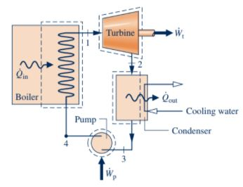



## Superheated Rankine Cycle:

Same as Ideal except state 1

1-2: Isentropic expansion from superheated vapor to condenser pressure $(p_{C})$

2-3: Isobaric condensation to a saturated liquid

3-4: Isentropic compression to subcooled liquid

4-1: Isobaric evaporation to superheated vapor

## Reheat Rankine Cycle:



Often used when combustion used to heat stage 5-6 produces extra energy

1-2: Isentropic expansion from superheated vapor to $p_{2}$

2-3: Isobaric heating using extra energy from an excess combustion

3-4: Isentropic expansion to $p_{c}$

4-5: Isobaric condensation to a saturated liquid

5-6: Isentropic compression to subcooled liquid

6-1: Isobaric evaporation to superheated vapor

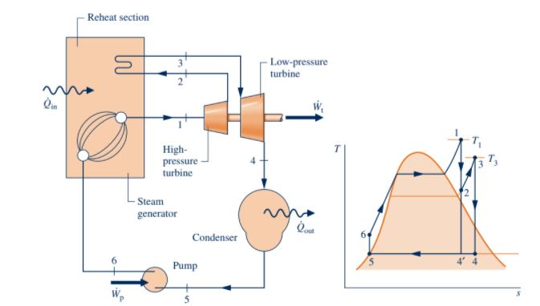

Regenerative Open Feedwater Heater:

$(y)=\frac{{\dot{m}}_{2}}{{\dot{m}}_{1}}$ $(1-y)=\frac{{\dot{m}}_{3}}{{\dot{m}}_{1}}$ $(1)=\frac{{\dot{m}}_{1}}{{\dot{m}}_{1}}$

$y=\frac{h_{6}-h_{5}}{h_{2}-h_{5}}$ $p_{5}=p_{6}=p_{2}$

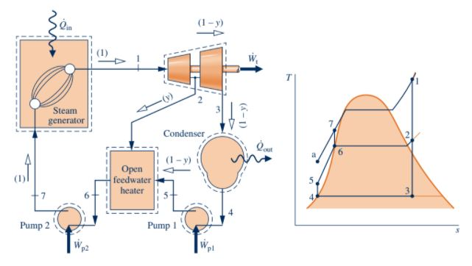

Closed Feedwater Heater:

$y=\frac{h_{6}-h_{5}}{h_{2}-h_{7}}$

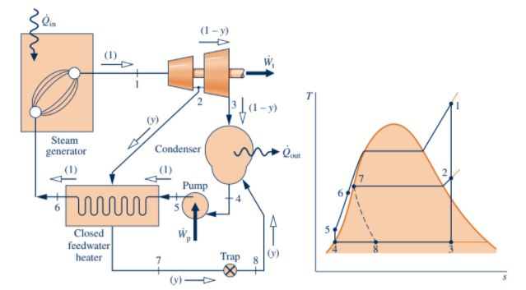

# Brayton Cycle:

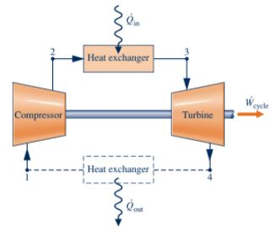

1-2 Adiabatic compression

2-3 Isobaric heating

3-4 Adiabatic expansion

4-1 Either lose to atmosphere modeled as isobaric heating

Cold Air Approx: contact spec heats at 300K

$η=\frac{{(h}_{3}-h_{4})+(h_{1}-h_{2})}{h_{3}-h_{2}}=1-\frac{1}{(\frac{p_{2}}{p_{1}})^{\frac{k-1}{k}}}$

Second part is only with cold air approx

$bwr=\frac{{\dot{W}}_{c}/\dot{m}}{{\dot{W}}_{t}/\dot{m}}$ 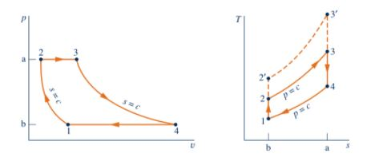

## Regenerative Gas Turbine:

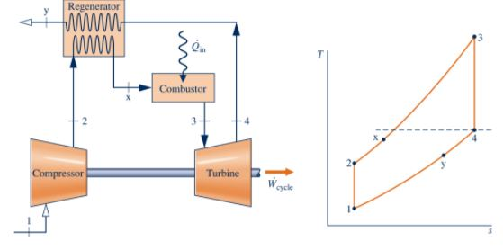

$η_{reg}=\frac{h_{x}-h_{2}}{h_{4}-h_{2}}$

If $η_{reg}=1$ then: $h_{x}=h_{4}$

$h_{x}=η_{reg}(h_{4}-h_{2})+h_{2}$

## Reheat gas turbines:

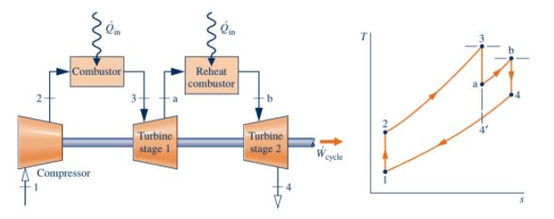

$p_{3}>p_{a}>(p_{4}=p_{1})$ Ideally $T_{b}=T_{3}$

## 

## 

## 

## Intercooled gas:

Idea is that isothermal is less work input for the same pressure raise.

Look at the shaded area that we avoided.

Adding intercooler approximates isothermal more

### Pressure ratio:

$r=\frac{p_{2}}{p_{1}}$

For turbines you want : $r=\frac{p_{1}}{p_{2}}$

## 

## Ericsson Cycle:

Infinite intercooling and reheating

# Reciprocating engine equations:

Volume ratio: $r=\frac{V_{BDC}}{V_{TDC}}=1+\frac{V_{d}}{V_{c}}$

## Break Power Output

Power at crankshaft: 4-stroke: ${\dot{W}}_{net}=n_{c}\frac{N}{2}W_{cycle}$ 2-stroke: ${\dot{W}}_{net}=n_{c}NW_{cycle}$

$n_{c}$ is the number of cylinders, $N$ is rev/sec

## Mean Effective Pressure:

$MEP=\frac{W_{cycle}}{V_{d}}$ $V_{displacement}=\frac{π}{4}Bohr^{2}⋅Stroke$

# Otto Cycle:

Volume ratio: $r=\frac{v_{1}}{v_{2}}$ Efficiency: $η=\frac{W_{cycle}}{Q_{in}}$ 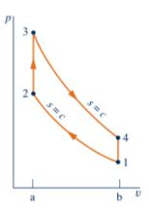

1-2: Isentropic compression of air in the piston(Compression stroke)

2-3: Isochoric heat addition. This is because fuel lighting combustion happens so fast, it is like the volume doesn’t change (start of power stroke)

3-4: Isentropic expansion of piston (finish of power)

4-1:Isochoric heat rejection (exhaust and intake)

Using $ΔU=Q-W$ yields:

$\frac{W_{1-2}}{m}=u_{1}-u_{2}=\int{}pdv$ $\frac{Q_{2-3}}{m}=u_{3}-u_{2}$

$\frac{W_{3-4}}{m}=u_{3}-u_{4}=\int{}pdv$ $\frac{Q_{4-1}}{m}=u_{1}-u_{4}$

## Cold Air Otto:

$η=1-\frac{T_{4}-T_{1}}{T_{3}-T_{2}}=1=\frac{1}{r^{k-1}}$

# Diesel cycle:

$r=\frac{v_{1}}{v_{2}}$ Cut off ratio: $r_{c}=\frac{v_{3}}{v_{2}}$ $η=\frac{W_{cycle}}{Q_{in}}$

1-2: Isentropic compression

2-3: Isobaric heat addition. Compression is needed to ignite injected fuel

3-4: Isentropic expansion

4-1: Isochoric heat rejection

$\frac{W_{1-2}}{m}=u_{1}-u_{2}=\int{}pdv$ $\frac{Q_{2-3}}{m}=p_{2}(v_{3}-v_{2})$ $\frac{Q_{2-3}}{m}=u_{3}-u_{2}+\frac{W_{2-3}}{m}=h_{3}-h_{2}$ because constant pressure

$\frac{W_{3-4}}{m}=u_{3}-u_{4}=\int{}pdv$ $\frac{Q_{4-1}}{m}=u_{1}-u_{4}$

Use ideal gas law to find states: $T_{3}=r_{c}T_{2}$

## Cold Air Diesel:

$η=1-\frac{u_{4}-u_{1}}{h_{3}-h_{2}}=1-\frac{1}{r^{k-1}}(\frac{{r_{c}}^{k}-1}{k(r_{c}-1)})$

# Dual Cycle:

Combined otto and diesel assumptions

$r=\frac{v_{1}}{v_{2}}$ $r_{c}=\frac{v_{4}}{v_{3}}$

$\frac{W_{1-2}}{m}=u_{1}-u_{2}=\int{}pdv$ $\frac{Q_{2-3}}{m}=u_{3}-u_{2}$

$\frac{W_{3-4}}{m}=p_{3}(v_{4}-v_{3})$ $\frac{Q_{3-4}}{m}=h_{4}-h_{3}$

$\frac{W_{4-5}}{m}=u_{4}-u_{5}$ $\frac{Q_{5-1}}{m}=u_{1}-u_{5}$

# Ideal Stirling cycle:

$η=1-\frac{T_{c}}{T_{H}}$

1-2: Isothermal heat addition

2-3: Isochoric regeneration (storing heat somewhere else)

3-4: Isothermal heat removal

4-1: Isochoric regeneration (take heat from the stored heat)

# Refrigeration cycles:

## Vapor-Compression refrigeration:

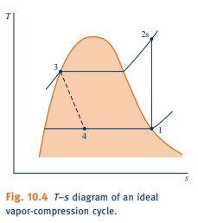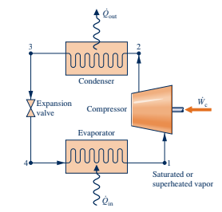

1-2: Isentropic/Adiabatic compression

2-3: Isobaric heat rejection

3-4: Isenthalpic/Adiabatic expansion

4-1: Isobaric heat addition

The “refrigerator” would be known as the cold reservoir. In order to ensure heat flow, the fluid at 4 must be colder than the cold reservoir and hotter than the hot reservoir at 3

Heat flows from fluid to hot reservoir

Heat flows from cold reservoir to fluid

$x_{1}=1$ and $x_{3}=0$

$β=\frac{{\dot{Q}}_{in}}{|{\dot{W}}_{cycle}|}$ $γ=\frac{{\dot{Q}}_{out}}{{\dot{|W}}_{cycle}|}$

# *Moist* Air

Dalton Model:

For water vapor (v) and air (a)

$V=V_{v}=V_{a}$ $T=T_{v}=T_{a}$ $p=p_{v}+p_{a}$

## Partial pressure

Arbitrary component (i): $p_{i}=\frac{n_{i}\bar{R}T}{V}$

$p_{i}=y_{i}p$

## Properties

$U=ΣU_{i}$ $H=ΣH_{i}$ $S=ΣS_{i}$

Arbitrary properties (B): $B=Σn_{i}{\bar{b}}_{i}=Σ m_{i}b_{i}$

Mass fraction and mole fraction: $mf_{i}=\frac{m_{i}}{m_{tot}}$ $y_{i}=\frac{n_{i}}{n_{tot}}$

$b=Σmf_{i}b_{i}$ $\bar{b}=Σy_{i}{\bar{b}}_{i}$

## Humidity ratio

$ω=\frac{m_{v}}{m_{a}}=0.622(\frac{p_{v}}{p-p_{v}})$

## Relative humidity

$ϕ=\frac{p_{v}}{p_{g}}$

$p_{g}=p(T_{v},x_{sat})$ $x_{sat}=1$

## Dew point temperature

$T=T(p_{v},x_{sat})$ 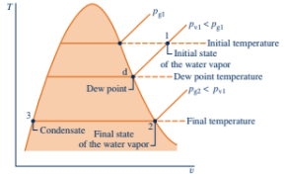

Dehumidifier

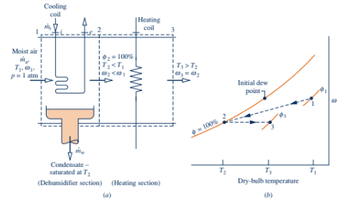

# Psychrometric chart:

Given a point:

Vertically down to axis: Dry-Bulb temp

Horizontally right to axis: Humidity ratio

Horizontally let to $ϕ=100\%$: Dew Point temp

Diagonally up/left to $ϕ=100\%$: Wet-Bulb temp